CUSTOMER JOURNEY MAP

# POSITIVE

**SERVICE**

**ACQUISITION**

Smart & Clean City

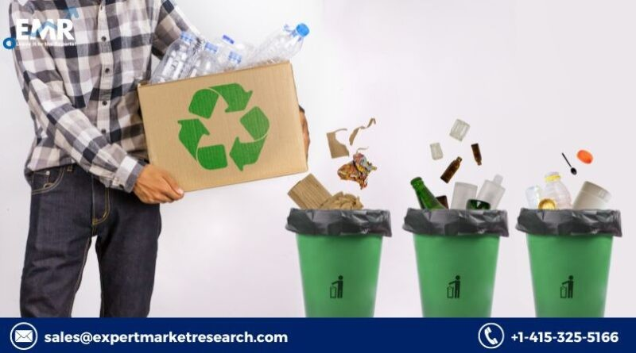

Reduce over flow

Dynamic management & routing

**CONSIDERATION**

**AWARENESS**

Reduce fuel consumption

Proper Disposal

Reduce over flow

**LOYALITY**

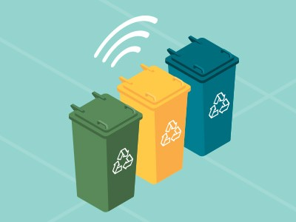

# NEGATIVE

Improper collection of waste

Unhygienic Environment

Due to Power cut improper communication

Sensor & Internet Management



